***WEEK 1 COGNIZANT LEARNING***

***ALGORITHMS AND DATA STRUCTURES***

***Exercise 2: E-commerce Platform Search Function***

***CODE –***

*using System;*

*using System.Collections.Generic;*

*using System.Linq;*

*class Product*

*{*

*public string Name { get; set; }*

*public string Category { get; set; }*

*public double Price { get; set; }*

*public Product(string name, string category, double price)*

*{*

*Name = name;*

*Category = category;*

*Price = price;*

*}*

*public override string ToString()*

*{*

*return $"Product: {Name}, Category: {Category}, Price: ₹{Price}";*

*}*

*}*

*class Program*

*{*

*static void Main()*

*{*

*List<Product> products = new List<Product>*

*{*

*new Product("Wireless Mouse", "Electronics", 699),*

*new Product("Bluetooth Speaker", "Electronics", 1299),*

*new Product("Running Shoes", "Footwear", 2499),*

*new Product("Cotton T-Shirt", "Apparel", 599),*

*new Product("Water Bottle", "Kitchen", 299)*

*};*

*Console.Write("Enter search keyword: ");*

*string keyword = Console.ReadLine().ToLower();*

*var results = products*

*.Where(p => p.Name.ToLower().Contains(keyword) || p.Category.ToLower().Contains(keyword))*

*.OrderBy(p => p.Price)*

*.ToList();*

*Console.WriteLine("\nSearch Results:");*

*if (results.Count == 0)*

*Console.WriteLine("No products found.");*

*else*

*results.ForEach(p => Console.WriteLine(p));*

*}*

*}*

***OUTPUT -***

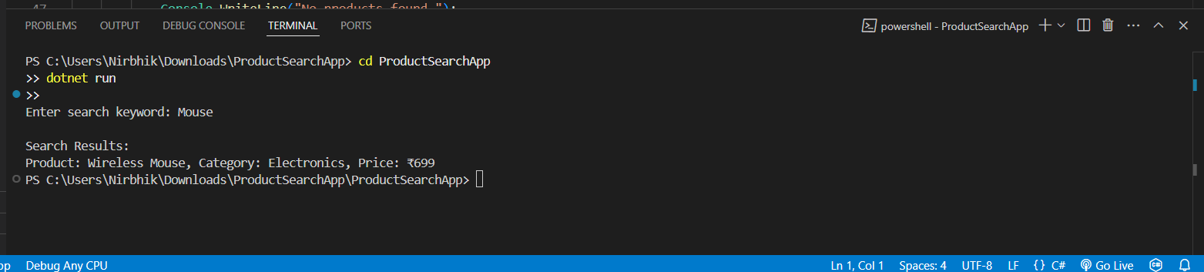

**Exercise 7: Financial Forecasting**

**CODE –**

using System;

class Program

{

    static double ForecastFutureValue(double amount, double growthRate, int years)

    {

        if (years == 0)

            return amount;

        return ForecastFutureValue(amount * (1 + growthRate), growthRate, years - 1);

    }

    static void Main(string[] args)

    {

        double startingAmount = 10000;

        double annualGrowthRate = 0.10;

        int totalYears = 5;

        double futureValue = ForecastFutureValue(startingAmount, annualGrowthRate, totalYears);

        Console.WriteLine($"Future value after {totalYears} years = ₹{futureValue:F2}");

    }

}

**OUTPUT –**

